Agreement Between All fields are mandatory

Company Name
Business Name |  |  |  | ABN
Business Address
Suburb |  | State |  | Postcode
Contact Name
Telephone |  | Mobile
Email
(hereinafter referred to as “the Supplier”), being a corporation or a natural person who supplies skips or bins within the City of Stonnington AND Stonnington City Council (hereinafter referred to as “the Council”).
Terms
The supplier agrees to and gives an unconditional undertaking to the Council that it shall:
- In every case apply for and obtain a permit under Council’s Local Law authorising the placement of a skip or bin on a road or other Council land before delivering the skip or bin;
- Comply with Council’s Skip/ Bin Standard Permit Conditions including those related to marking of bins with reflective tape complying with the prescribed specifications and the attached illustrations;
- Comply with any special conditions that Council applies to any permit;
- Pay for permits issued within 21 days of invoicing;
- Indemnify the relevant responsible road authority (being either Council or VicRoads depending on where the bin is located) should there be any claim for any damage arising from the placement of any skip/bin;
- Maintain current at all times a Public Liability Insurance Policy related specifically to the skip / bin service provided with a minimum cover of $10 million – proof of the current policy is provided with this agreement;
- Pay for any damage caused to the road surface or other public assets arising from the placement of any skip / bin;
- Ensure that staff or any person that (on their instructions or behalf) delivers, empties or picks up skips / bins are aware of and observe Council’s permit conditions; and,
- Acknowledge that this agreement may be cancelled without notice if any of these undertakings are not observed.
The Council agrees, from the date it signs this agreement, that it shall issue permits on credit allowing no more than 21 days after invoicing for payment to be made by the supplier in each case.
Signatures
SIGNED BY THE SUPPLIER ON BEHALF OF THE CORPORATION NAMED ABOVE OR BY THE OWNER(S) OF THE BUSINESS NAMED ABOVE AS THE SUPPLIER:

Signature of Applicant |  | Date
Print Name

If the supplier is an incorporated entity, the person signing this agreement acknowledges that he or she does so with the express authority of the entity.
SIGNED ON BEHALF OF STONNINGTON CITY COUNCIL:
Privacy Statement: Personal information required on this form is for processing the Local Law Permit Application and will only be used by the Council for that purpose or a directly related purpose. After lodging the application, the applicant may obtain access to the information supplied and may amend the information. Requests for access may be made to Council’s Privacy Officer (Council general phone number 8290 1333).

 | Signature of Authorised Officer |  |  |  | Date
 | Print Name

A standard condition that applies to all City of Stonnington Local Law Skip / Bin Permits requires that the skip or bin be marked with reflective tape complying with VicRoads standards. An extract from a VicRoads “Code of Practice for the Placement of Waste Bins on Roadsides” is reproduced below to indicate what is required.

REFLECTIVE MARKING OF WASTE BINS
The pattern to be used is an inverted “L” located as close as practical to each top corner of the bin to identify its length, width and height.  Markings at opposite ends of each side shall be placed at the same relative height. |  |  |  | The material must be:  - at least 50 mm wide, and  - a minimum horizontal length of 200 mm and 350 mm high
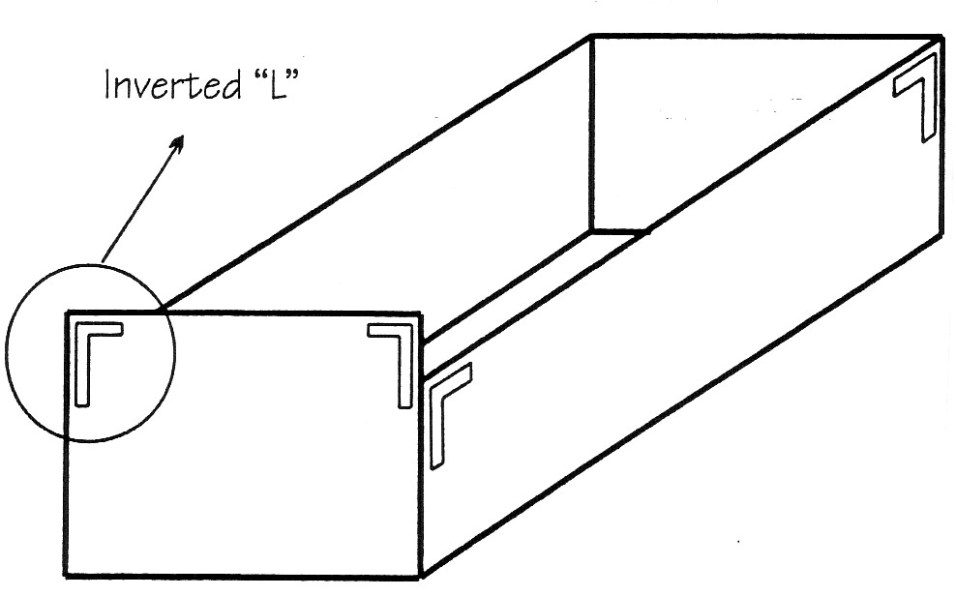 |  |  |  | 200 mm  50 mm  350 mm
The inverted “L” allows an approaching driver to ascertain bin orientation and placement. |  |  |  | The horizontal stem of the “L” is to face inwards.  All sides of the bin are to be delineated
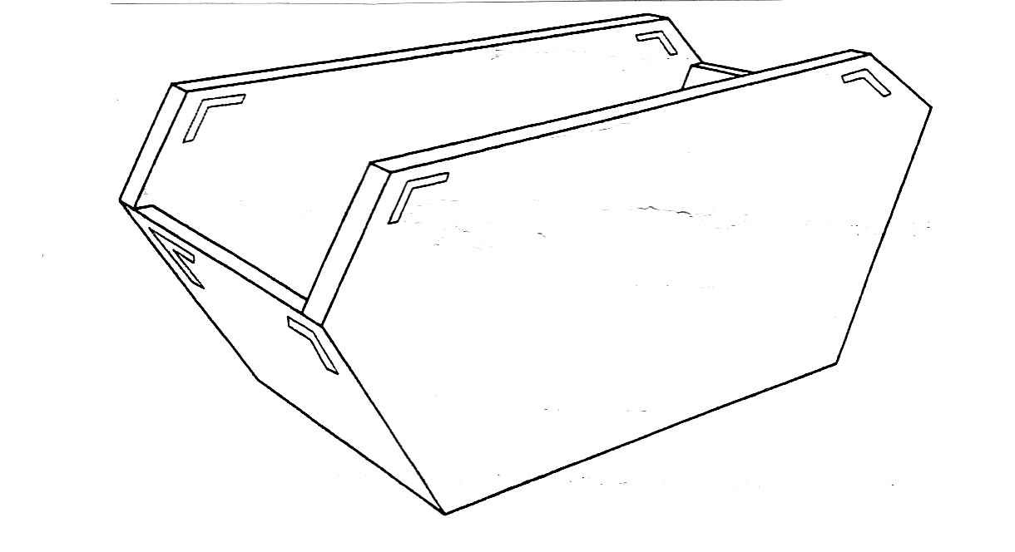 |  |  |  | Waste bins are not required to have rear red / yellow marking plates or “Do Not Overtake Turning Vehicle” signs. These marking plates appear on the vehicles transporting the bins.  The inclusion of such plates on a bin does not remove the onus on the hirer to attach retroreflective tape as described below. If rear red / yellow marking plates are already incorporated on bins, then placement of the bin on the roadway shall be in the correct direction relative to passing traffic (ie red / yellow marking plates are to the left of passing vehicles).
The tape may be placed at angles other than 90 degrees to enhance the general appearance of the waste bin. |  |  |  | The material to be used shall be micro prismatic retroreflective yellow material, bearing the European “E” marking on “C” class material. “C” class material is used for contour / strip marking and has specific retroreflective properties.  The material shall be pressure sensitive and applied in accordance with manufacturer’s specifications and instructions.

