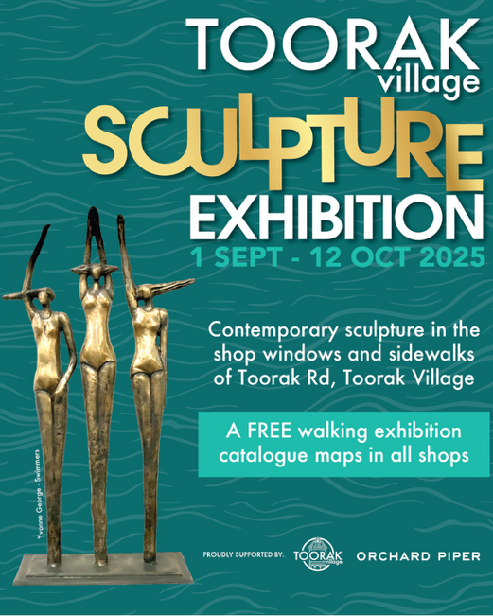

**TOORAK VILLAGE SCULPTURE EXHIBITION**

**MEDIA RELEASE: AUGUST 2025**

**AUSTRALIAN MADE CONTEMPORARY SCULPTURE IN THE SHOP WINDOWS AND SIDEWALKS OF TOORAK ROAD, TOORAK VILLAGE**

Starting Sunday 1st September to Sunday 12th October, the Toorak Village Sculpture Exhibition is a 6-week arts event where Toorak Village is turned into a 'Street Gallery'. Contemporary sculptural works are exhibited in the shop windows of the small businesses along Toorak Road and side streets, with large sculptures bolted along the sidewalks of Toorak Village.

The 2025 exhibition will showcase 97 unique sculptures by 97 sculptural artists who carefully place their works amongst the merchandise in our shop windows and along the sidewalks. It is a walking exhibition with a printed Catalogue with Map to steer visitors to all artworks, available in the shops.

The Toorak Village Sculpture Exhibition was initiated by **Ken Scarlett OAM** and **Xenia Holt** in 2002 who excited the committee of the business association to stage an innovative exhibition of sculpture, linking the arts with business. This will be the 22nd year of exhibiting Australian made sculpture and supporting 1000’s of artists in the Toorak Village over the years. This is a free exhibition, and all sculptures are original and available for sale.

The exhibition is managed by the **Toorak Village Traders Association** and will be curated by **Malcolm Thomson,** an experienced arts professional with over 40 years of curatorial experience in the field of sculpture. He will engage and support both the artists and the businesses in making the village a unique destination for sculpture. The invited Judge this year is**Caroline Field,**an Australian curator and writer specialising in twentieth century art writing and research, collection development, exhibitions, visual art projects and museum policy.

Caroline will judge the 3 non-acquisitive prizes totalling $15,000 with the overall winner receiving $10,000, awarded at a gala opening event in the village. This year the $10,000 winning prize is proudly sponsored by **Orchard Piper.**

The Toorak Village Sculpture Exhibition is presented and managed by the **Toorak Village Traders Association,** proudly supported by **Orchard Piper** and the businesses of Toorak Village.

…………………………………………………………………………………………………………………………………………………………………………………..

View: <https://www.toorakvillage.com.au/sculpture>

Exhibition Enquiries: Tracey Cammock - 0455 0455 45

Email: [tracey@toorakvillage.com.au](mailto:tracey@toorakvillage.com.au)

Exhibition Curator: Malcolm Thomson - 0409 434 923

